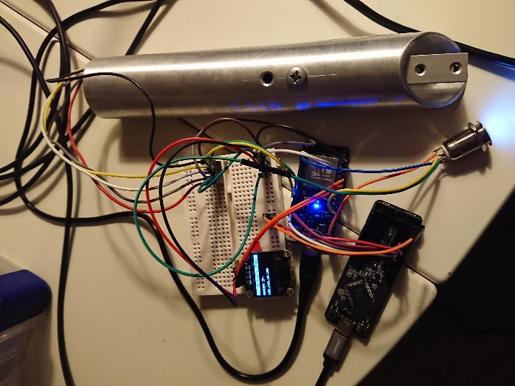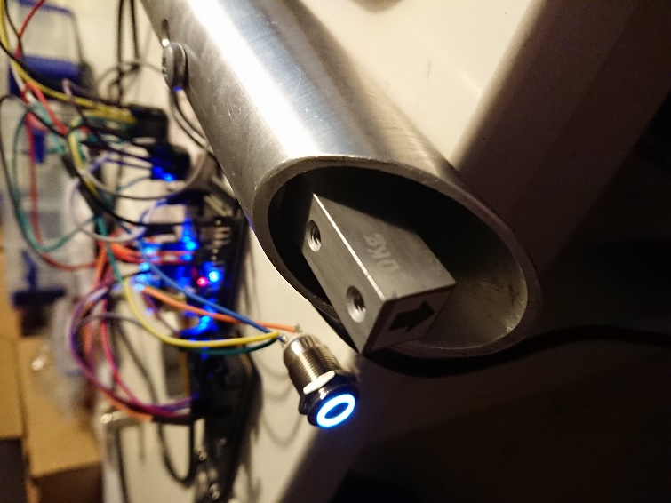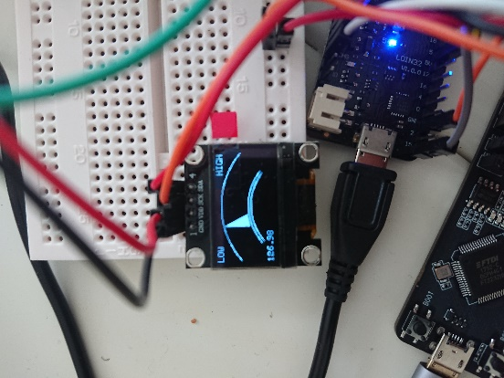

Table of Contents

Introduction 3

Assembly guide 4

Prerequisite 4

Software 4

PlatformIO 4

GitHub project 4

Uploading the firmware 6

Hardware 8

Tools 8

Components 8

3D printed parts 9

Component Links 9

Assembly 11

Lolin ESP32 11

Load cell 12

HX711 13

LED button 14

OLED 15

Bottom USB panel 16

Wire harness 17

Assembly of componets 18

Pre TEST before complete assembly 26

Completing assembly 30

Troubleshooting 31

# Introduction

This document describes the materials, components, and software to use in order to assemble the algometer, used in the pain research project.

The device is designed to provide wireless capabilities and connection to a redcap database to save the test data. The device itself host a webserver, which presents the test procedure to be followed for this research project.

The main purpose is to capture pressure data, provide instructions to the patient in the test to be executed, and deliver an easy way to produce consistent test results, by the means of streamlining the test cases.

# Assembly guide

## Prerequisite

## Software

### PlatformIO

This project was developed with the opensource software extension for Visual Studio Code, named PlatfomIO.

A descriptive guide on the installation process can be found following this link:

<https://docs.platformio.org/en/latest/ide/vscode.html#installation>

### GitHub project

The PlatformIO project-based firmware, running on the device, can be found following this link:

<https://github.com/MortenBrask/Pressure_Probe>

* Download the project to any desired location
* Open Visual Studio Code, PlatformIO should start with a welcome screen.

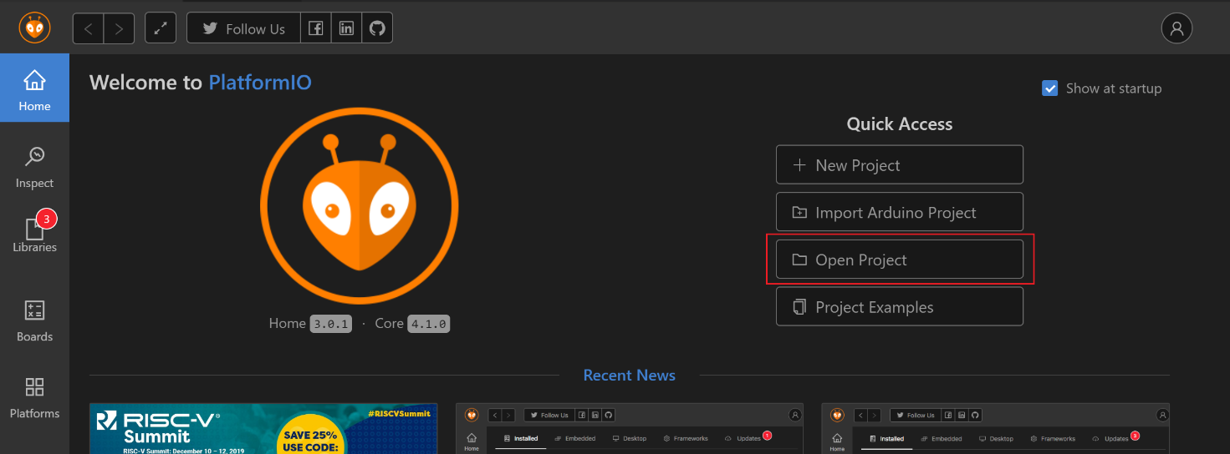Click ‘Open Project’ and navigate to the downloaded github project

* The navigator should now have the entire project listed

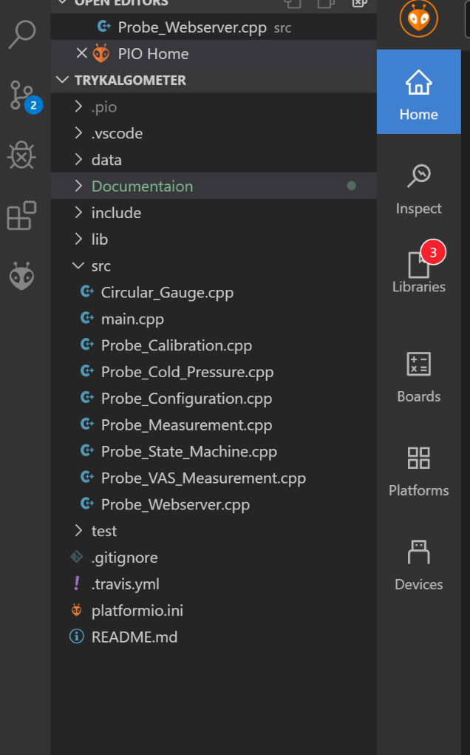

### Uploading the firmware

In order to flash the ESP32, connect the ESP32, and press the ‘Upload’ button which resides in the blue bottom taskbar of PlatformIO, and looks like an arrow pointing to the right.

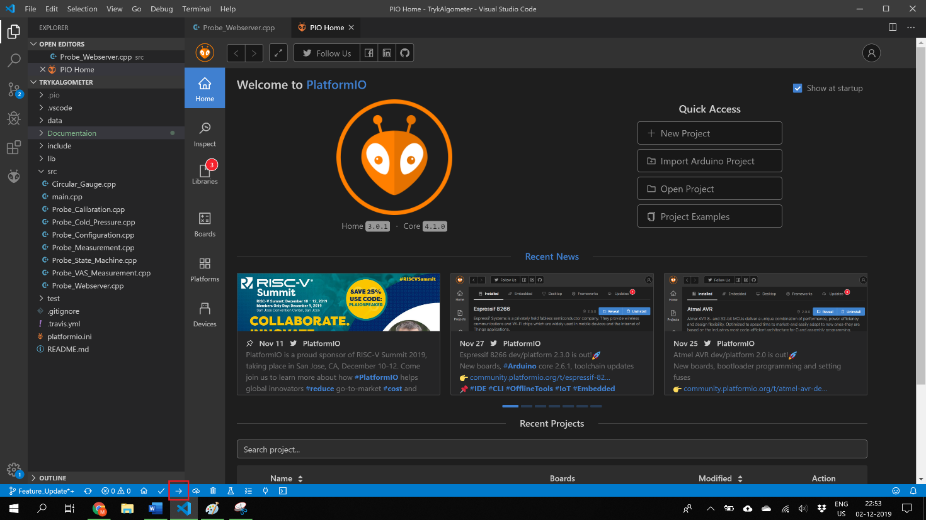

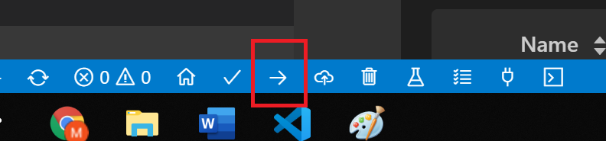

If errors occur, it is likely that some libraries needs to be installed before a succesfull compile is achieved. The affected library is most likely the ‘websocket.h’ file. Which can be found in the LIBS folder. Copy the library to the library folder of Platform IO and recompile.

When the software is uploaded, the external files should be uploaded to the Flash Files System of the ESP32.

Press the ‘Run Tasks” button and select ‘Upload File System Image’ from the dropdown.

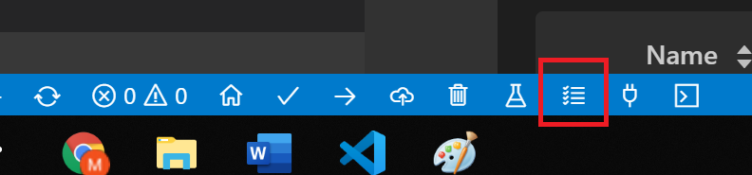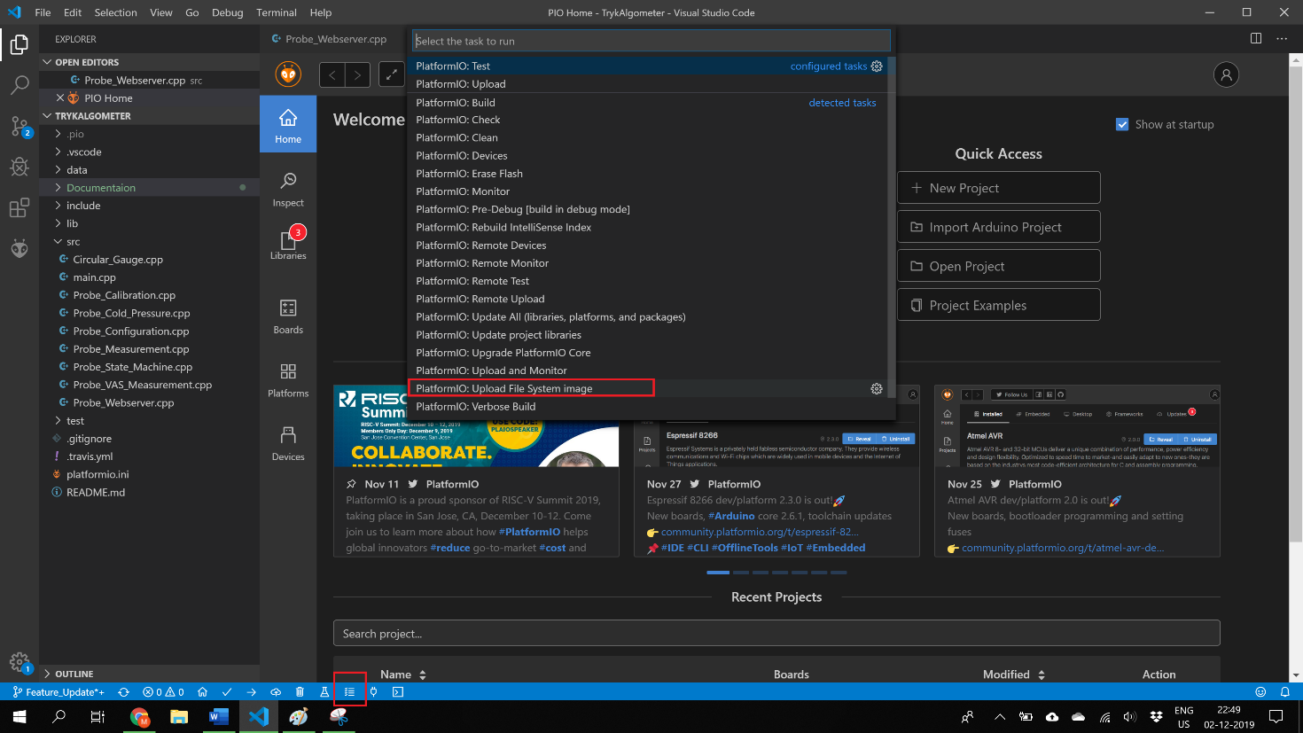

This will upload all the HTML, CSS, and various other files needed for the device to function properly.

## Hardware

### Tools

Various tools are needed in order to assemble a single unit, some of the tools may or may not be required or can be fulfilled by other means. The following lists the tools required for a smooth assembly:

* Soldering iron
* Solder
* Cable stripper
* Zip ties
* Crimp tool
* Shrink tube with solder
* Shrink tube min 19mm, or nonconducting tape
* 3D printer (4 printed parts is part of the build)
* Various screwdrivers with heads dependant on the screws chosen
* Nose pliers

### Components

Following is a complete list of the components used in the build, and links to the corresponding component:

|  |  |  |  |
| --- | --- | --- | --- |
| **1x Lolin D32, ESP32 development board** |  | **1x HX711, load cell amplifier** |  |
| **1x 10 Kg Load cell** |  | **1x 12mm LED Latching pushbutton** |  |
| **1x Adafruit micro USB panelmount** |  | **1x 0.96” OLED I2C display** |  |
| **8x 30cm Jumper Wire, Female to Female** |  | **2x 10cm Jumper Wire, Female to Female** |  |
| **2x 10cm Jumper Wire, Male to Male** |  | **2x M2 x 4mm machine screw** |  |
| **1x M2 nut** |  | **1x M2 x 6mm machine screw** |  |
| **2x M4 x 16mm** |  | **1x M4 x 6mm machine screw** |  |
| **20x 90 degree Pin Header, 2.54mm** |  | **10x straight Pin Header, 2.54mm** |  |
| **1x 3.7V LiPo battery** |  | **4x Crimp Header Terminals** |  |
|  |  |  |  |

### 3D printed parts

The assembly consist of 4, 3D printed parts.

* Top assembly
* Bottom assembly
* Aluminium tube spacer
* Lolin D32 and load cell spacer

The .STL files are located in the 3D folder.

### Component Links

* **1x Lolin D32, ESP32 development board** <https://www.aliexpress.com/item/32808551116.html?spm=2114.12010612.8148356.3.7de9667bvOHkMl>
* **1x HX711, load cell amplifier** <https://www.aliexpress.com/item/32848866947.html?spm=2114.12010615.8148356.1.686b48ac4pEAVO>
* **1x 10 Kg Load cell** <https://www.aliexpress.com/item/32949395083.html?spm=2114.12010615.8148356.1.2cad70eeDpNp8A>
* **1x 12mm LED Latching pushbutton** <https://www.aliexpress.com/item/32945377096.html?spm=a2g0s.9042311.0.0.362a4c4dVHYnRZ>
* **1x Adafruit micro USB panelmount** <https://www.adafruit.com/product/3258>
* **1x 0.96” OLED I2C display** <https://www.aliexpress.com/item/32902463963.html?spm=a2g0s.9042311.0.0.27424c4d3bTmO2>
* **8x 30cm Jumper Wire, Female to Female** <https://www.aliexpress.com/item/32962785036.html?spm=2114.12010615.8148356.1.71c7730c4DUeBp>
* **2x 10cm Jumper Wire, Female to Female** <https://www.aliexpress.com/item/32962785036.html?spm=2114.12010615.8148356.1.71c7730c4DUeBp>
* **2x 10cm Jumper Wire, Male to Male** <https://www.aliexpress.com/item/32962785036.html?spm=2114.12010615.8148356.1.71c7730c4DUeBp>
* **1x M2 x min 4mm machine screw** <https://uk.farnell.com/c/fasteners-mechanical/fasteners-fixings/screws-bolts/machine-screws?thread-size-metric=m2>
* **1x M2 nut** <https://uk.farnell.com/search?st=m2%20nut>
* **1x M4 x 6mm** <https://uk.farnell.com/w/c/fasteners-mechanical/fasteners-fixings/screws-bolts/machine-screws?st=m4%20screw&ost=M4%20screw>
* **2x M4 x 16mm** <https://uk.farnell.com/w/c/fasteners-mechanical/fasteners-fixings/screws-bolts/machine-screws?st=m4%20screw&ost=M4%20screw>
* **4x Crimp Header Terminals** <https://www.aliexpress.com/item/32960693762.html?spm=a2g0o.store_home.productList_8947779.pic_8>
* **20x 90 degree Pin Header, 2.54mm** <https://www.aliexpress.com/item/32856536650.html?gps-id=pcStoreJustForYou&scm=1007.23125.122752.0&scm_id=1007.23125.122752.0&scm-url=1007.23125.122752.0&pvid=bc8eea78-f8cd-41bf-bf3c-d4b60c50aaae&spm=a2g0o.store_home.smartJustForYou_99425223.1>
* **10x straight Pin Header, 2.54mm** <https://www.aliexpress.com/item/32856484890.html?gps-id=pcStoreJustForYou&scm=1007.23125.122752.0&scm_id=1007.23125.122752.0&scm-url=1007.23125.122752.0&pvid=bc8eea78-f8cd-41bf-bf3c-d4b60c50aaae&spm=a2g0o.store_home.smartJustForYou_99425223.2>
* **1x 3.7V LiPo battery** <https://www.aliexpress.com/item/32859283434.html?spm=a2g0o.productlist.0.0.11916044SDLtea&algo_pvid=a7087df0-ee0b-47a6-8cfb-b7ff3c001396&algo_expid=a7087df0-ee0b-47a6-8cfb-b7ff3c001396-6&btsid=db88c5c8-4212-46ec-958a-c3218b9c68ca&ws_ab_test=searchweb0_0,searchweb201602_1,searchweb201603_55>

## Assembly

### Lolin ESP32

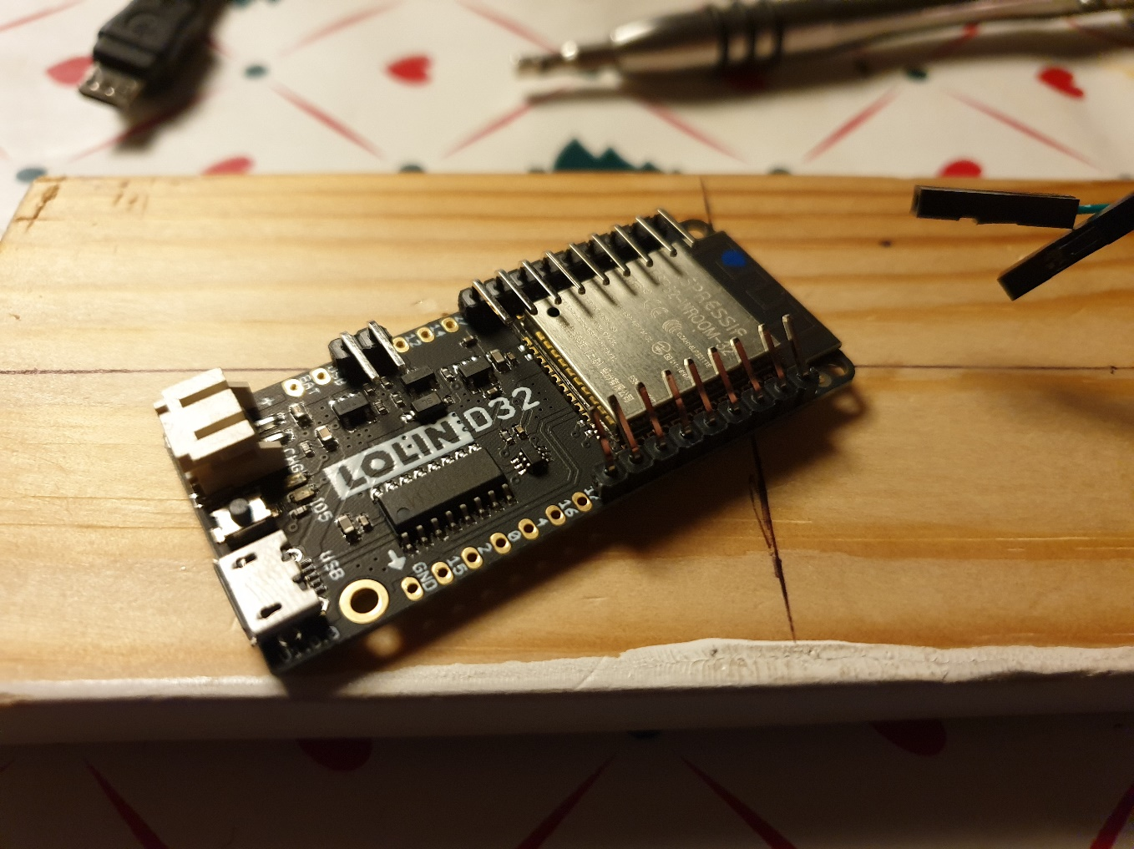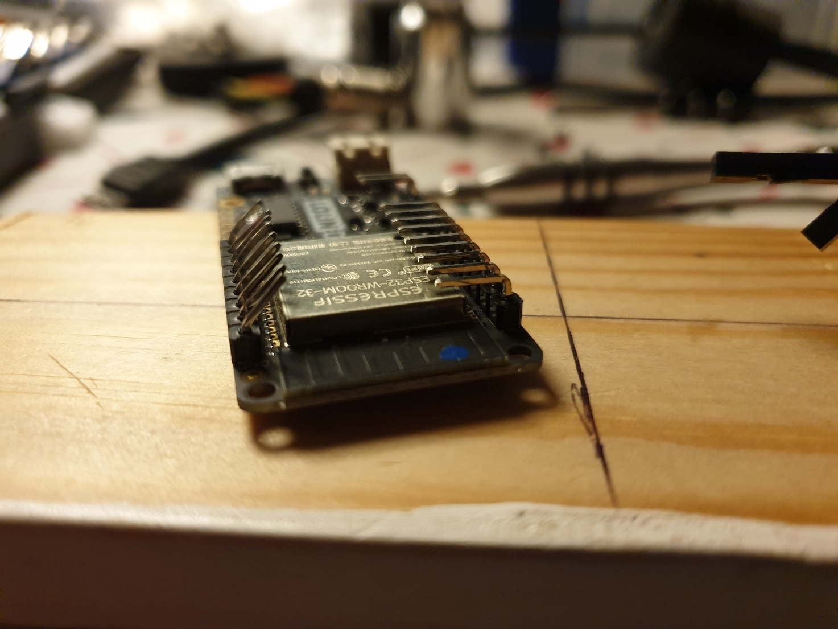Solder the 9 straight, and 9, 90 degree bend pins pin headers on the board starting from 3.3V and Ground. Solder 2 90 degree header pins on the EN pin, and the I/O pin next to the EN pin. Bend the straight header pins to an angle.

### Load cell

Cut and strip the 4 wires, and crimp on pin header terminals on each wire

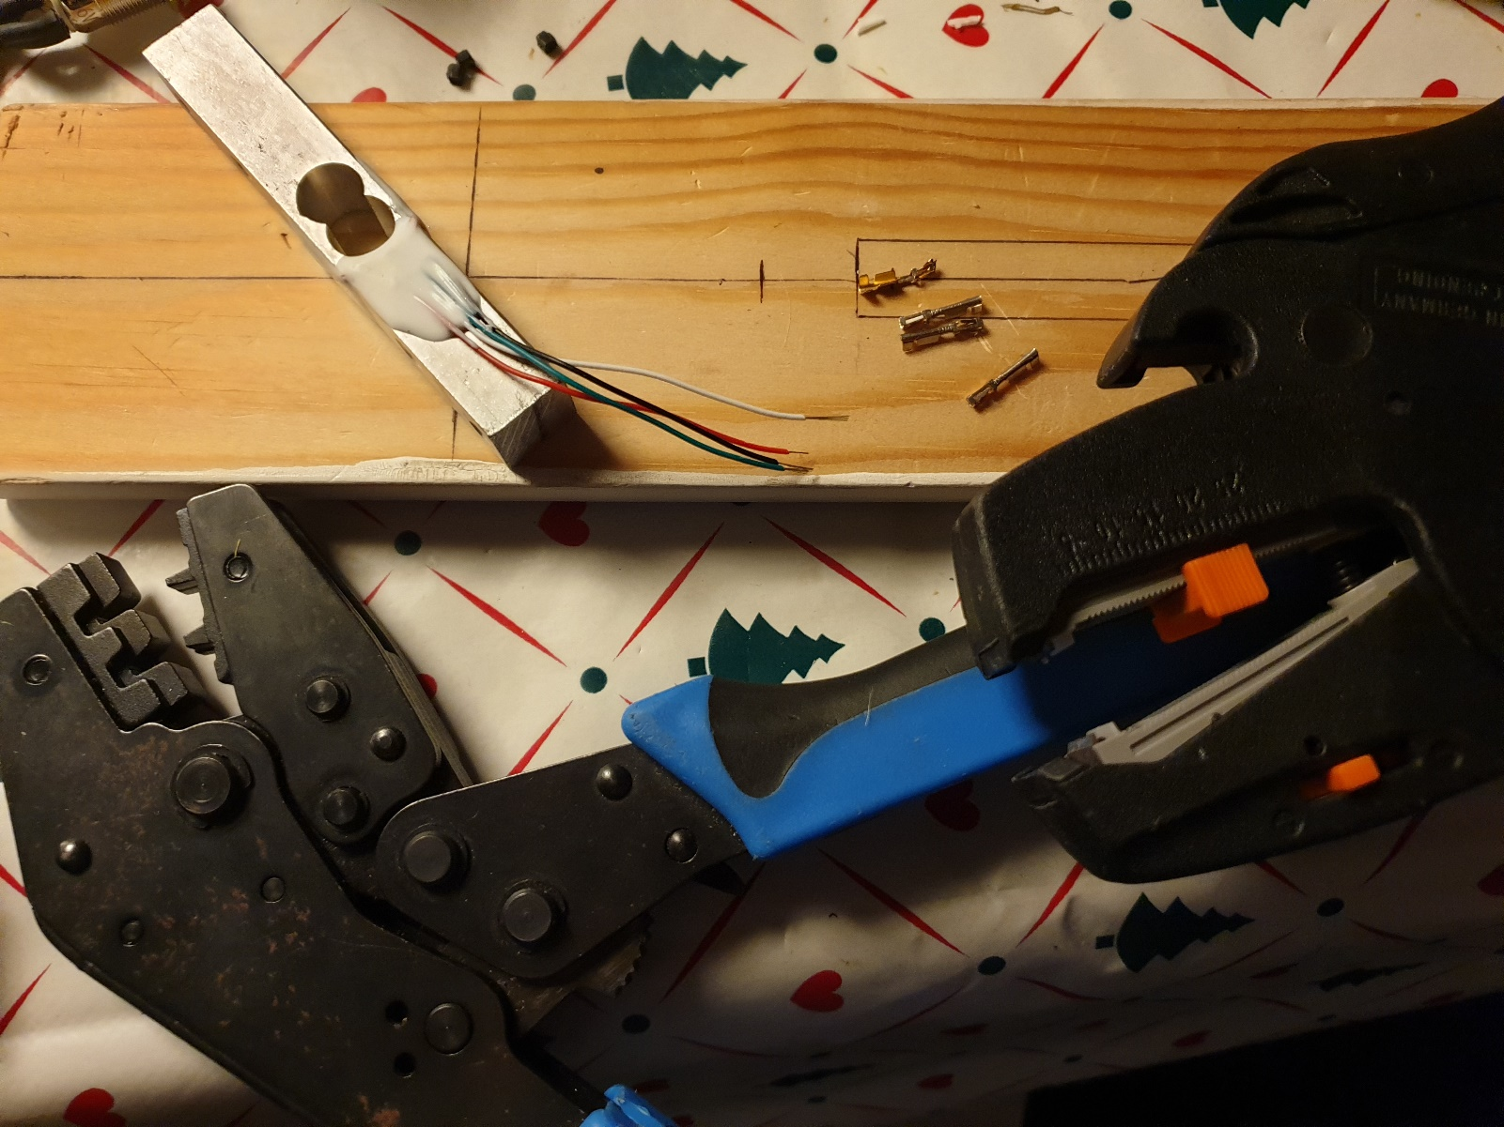

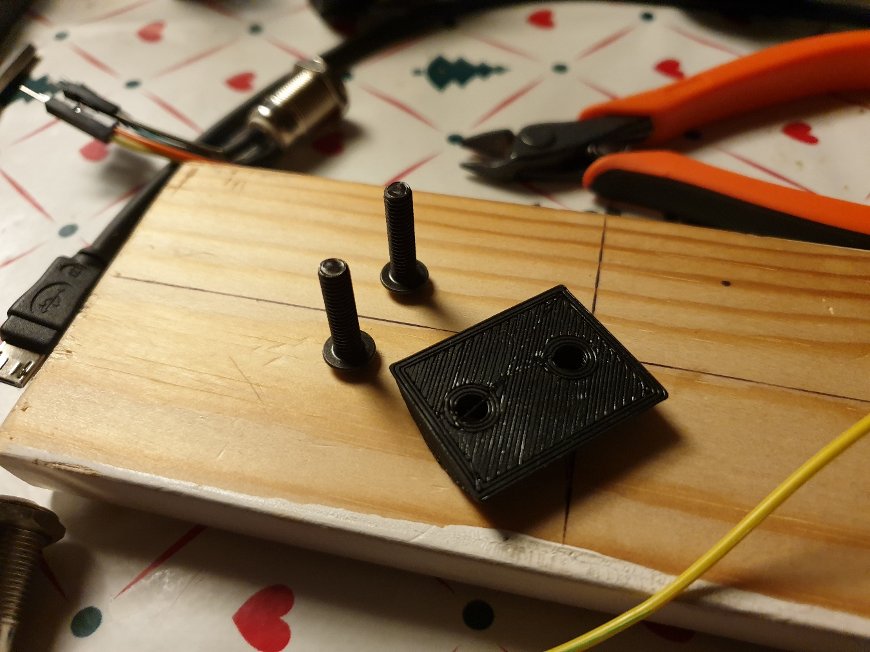Fasten the load cell on a piece of wood for easier assembly, remember the 3D printed spacer.

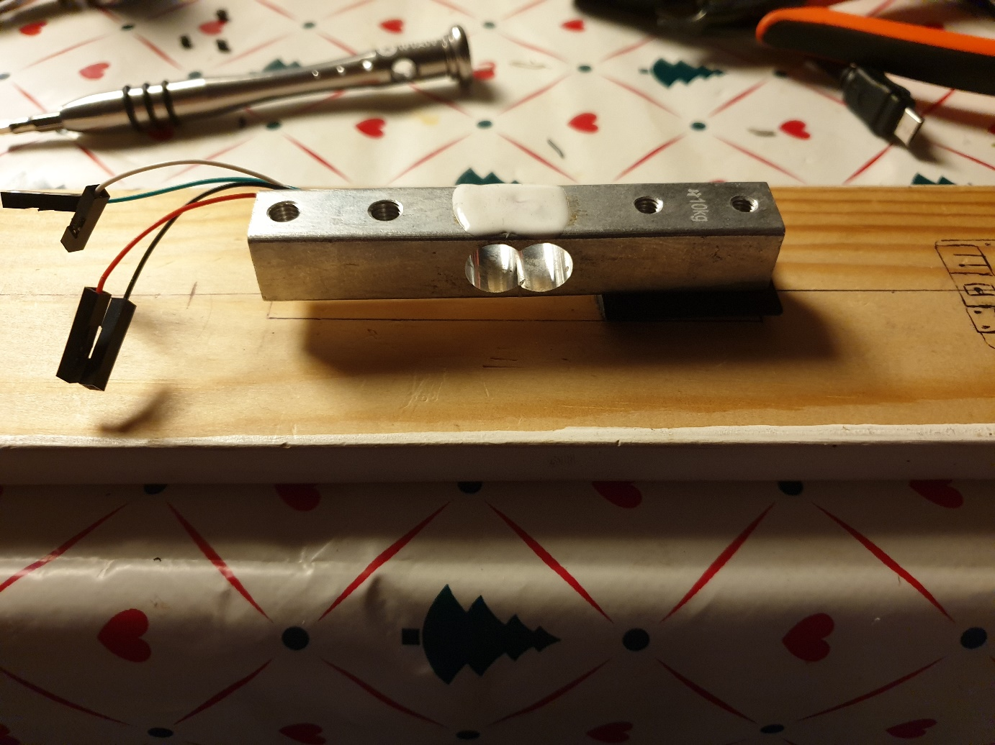

### HX711

Solder 4 90 degree bend pin headers on each side of the HX711 amplifier, discarding the ‘YLW’ pin.

Pull some shrinktube over the HX711, this is to prevent shortening inside the aluminium tube.

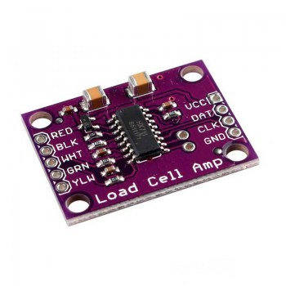 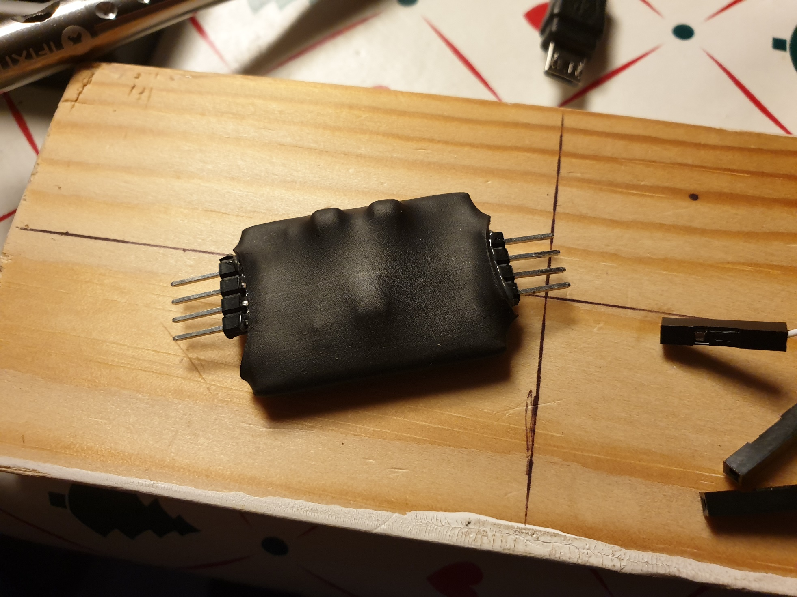

### LED button

Solder on 4 cut male jumper wire on each terminal of the button. Take note of the connections. Pull some shrinktube over the solderjoints to enhance durability, and prevent shorts. Bend the wires to achieve an approximate 90 degree bend.

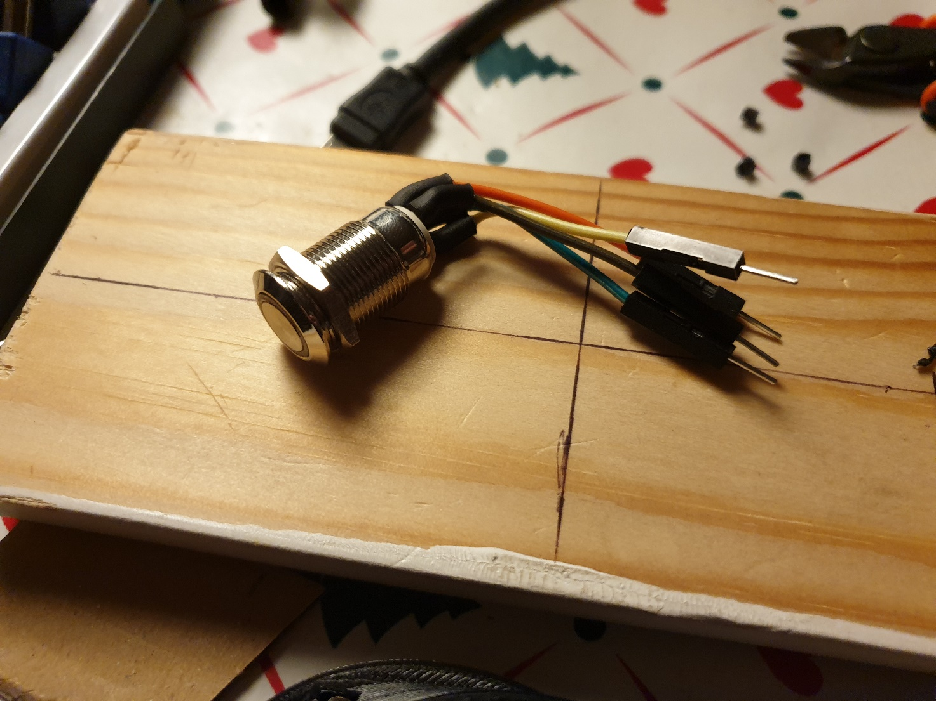

### OLED

Cut the plastic from the pin headers, and bend the pins. Insert the OLED display in the 3D printed Top assembly, and fasten 2 M2x4mm screws to secure the display.

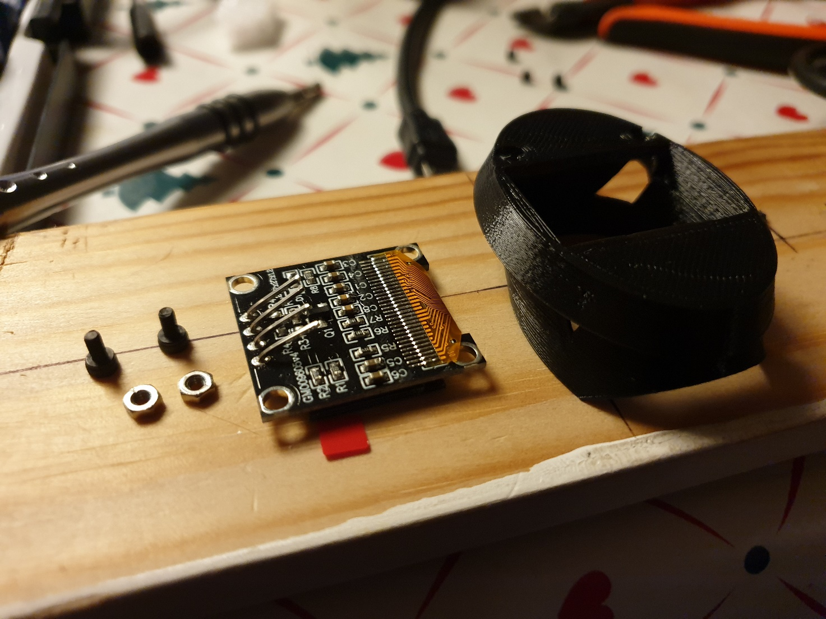

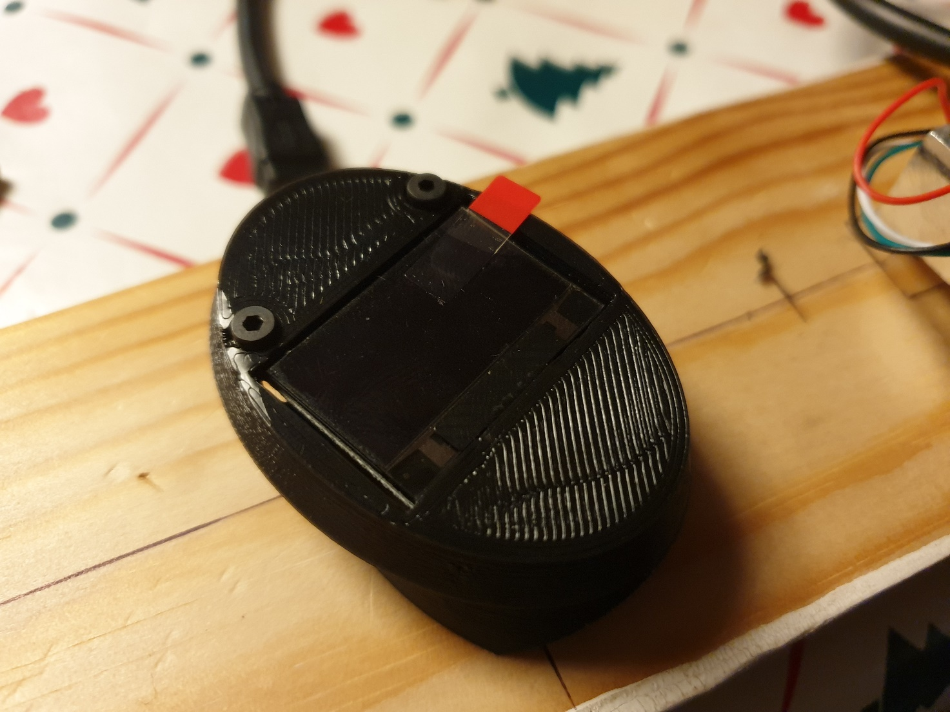

### Bottom USB panel

Insert the micro USB panel inside the 3D printed bottom, and tighten with the screws.

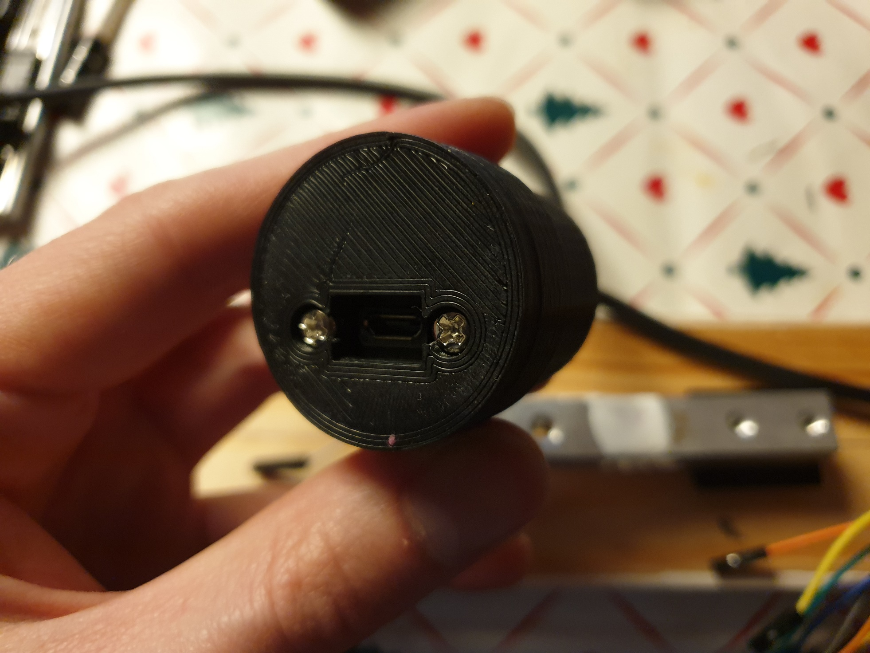 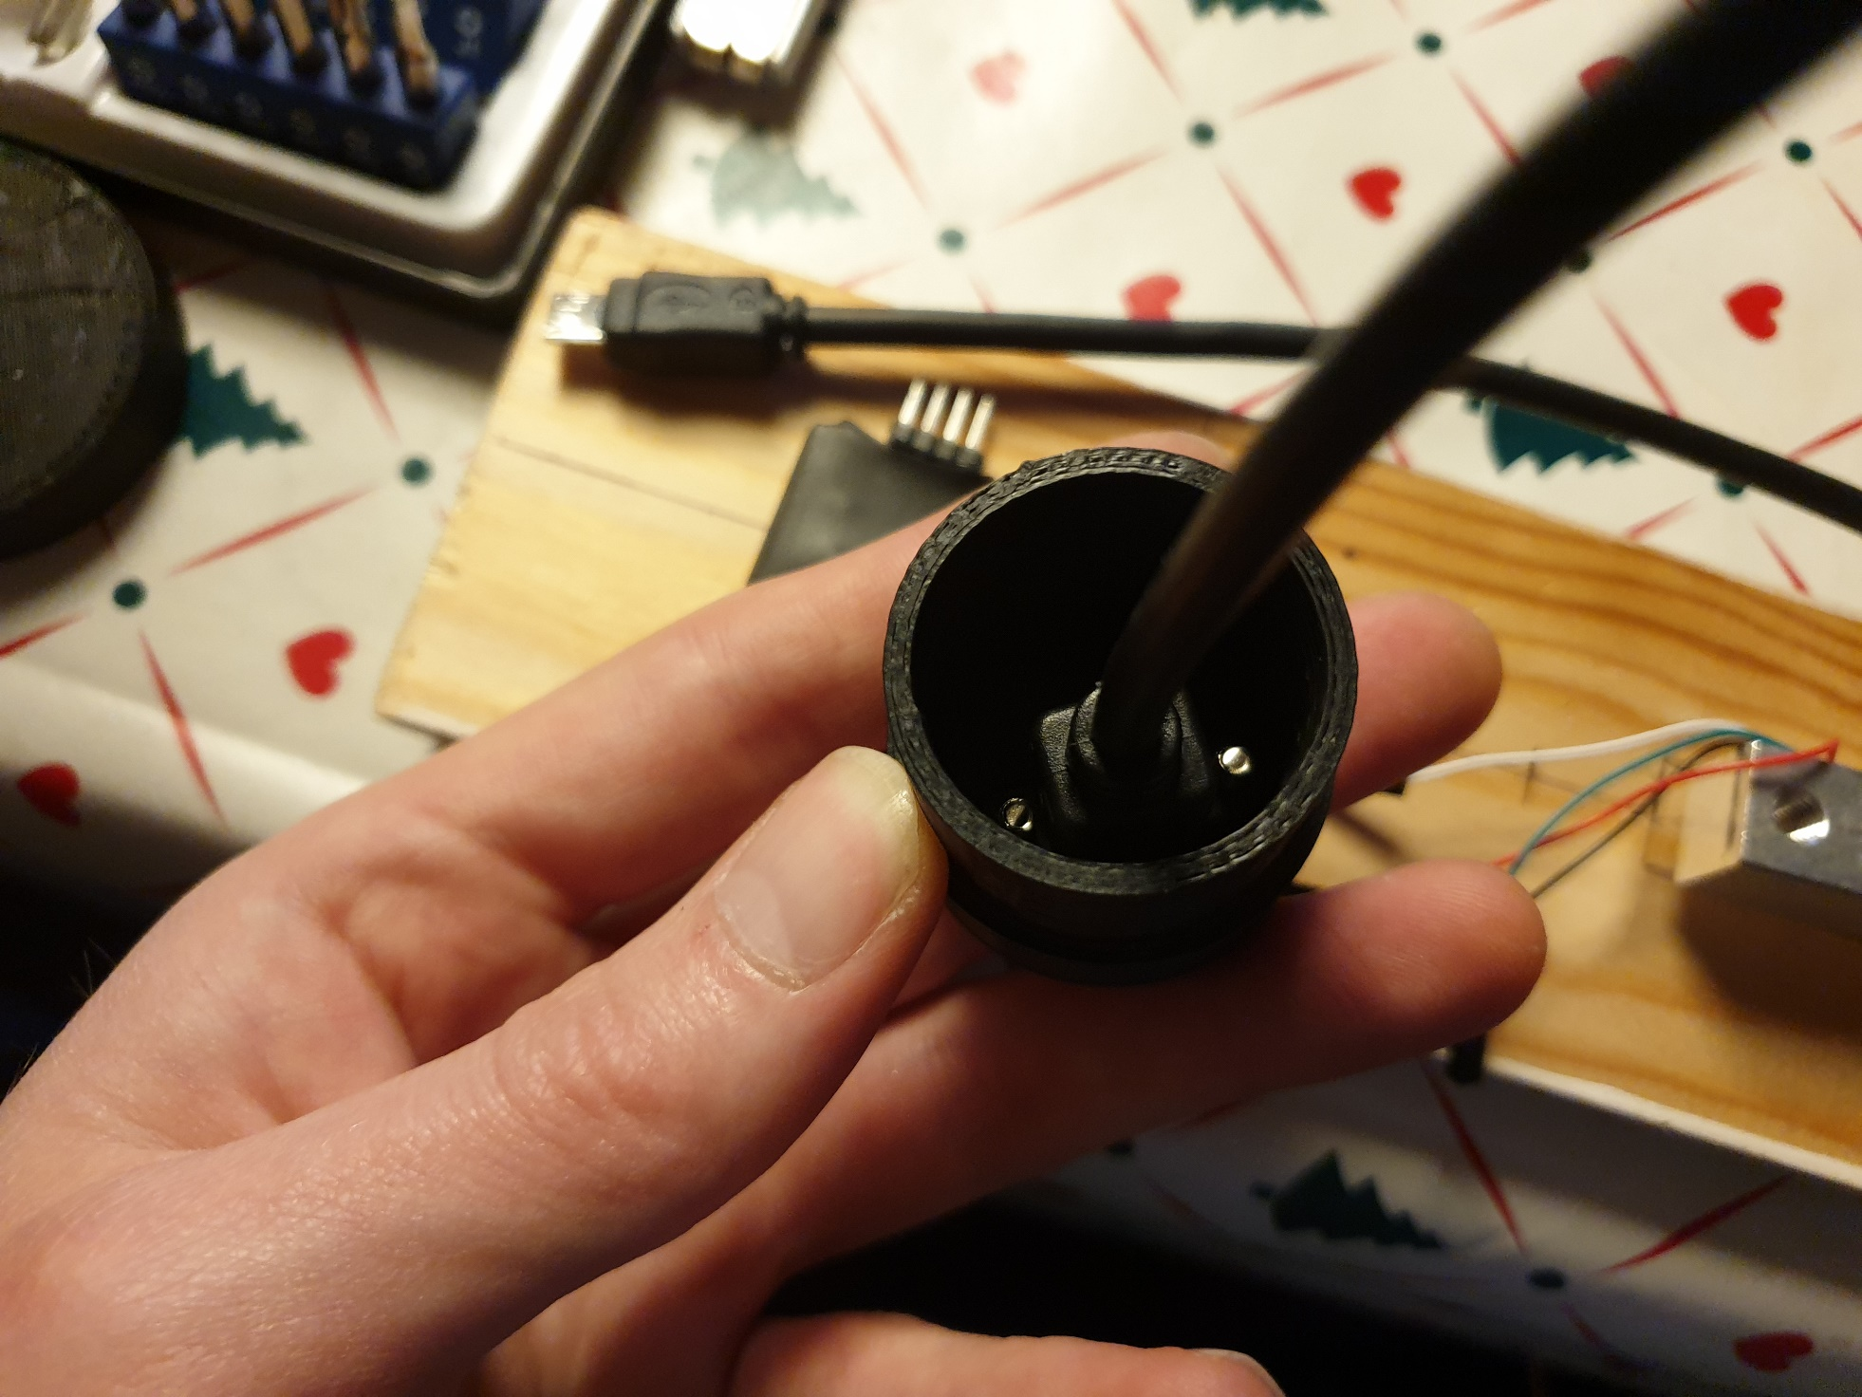

### Wire harness

The wire harness consists of 8, 30cm female to female jumper wires, and 2, 10 cm female to female jumper wire.

Take 4, 30 cm jumper wire and cut them in half, strip 5mm of insulation off each wire. Make 2 double pin wires, by inserting 2 halfs in each end of a solder shrink tube.

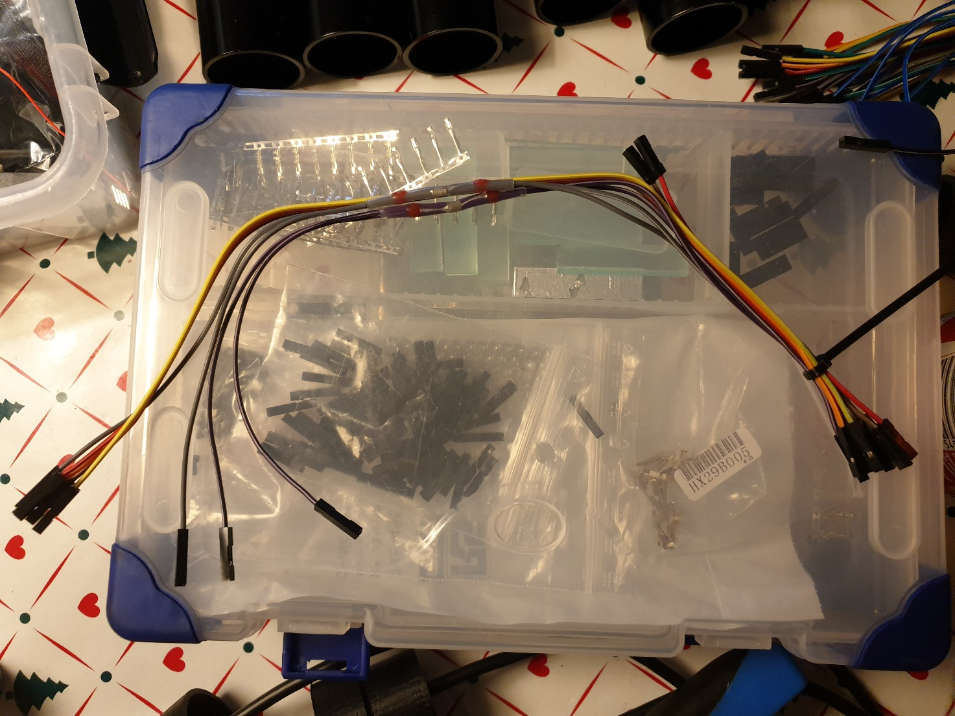

The end result should be similar to the above picture.

### Assembly of componets

#### Wiring Lolin D32

Connect the wire harness to the Lolin D32 board with the following connections:

* 1x dual jumper wire on 3.3V
* 1x dual jumper wire on GND
* 1x 30 cm jumper wire on SDA
* 1x 30 cm jumper wire on SCL
* 1x 30 cm jumper wire on pin 5
* 1x 30 cm jumper wire on EN
* 1x 10 cm jumper wire on pin 26
* 1x 10 cm jumper wire on pin 25

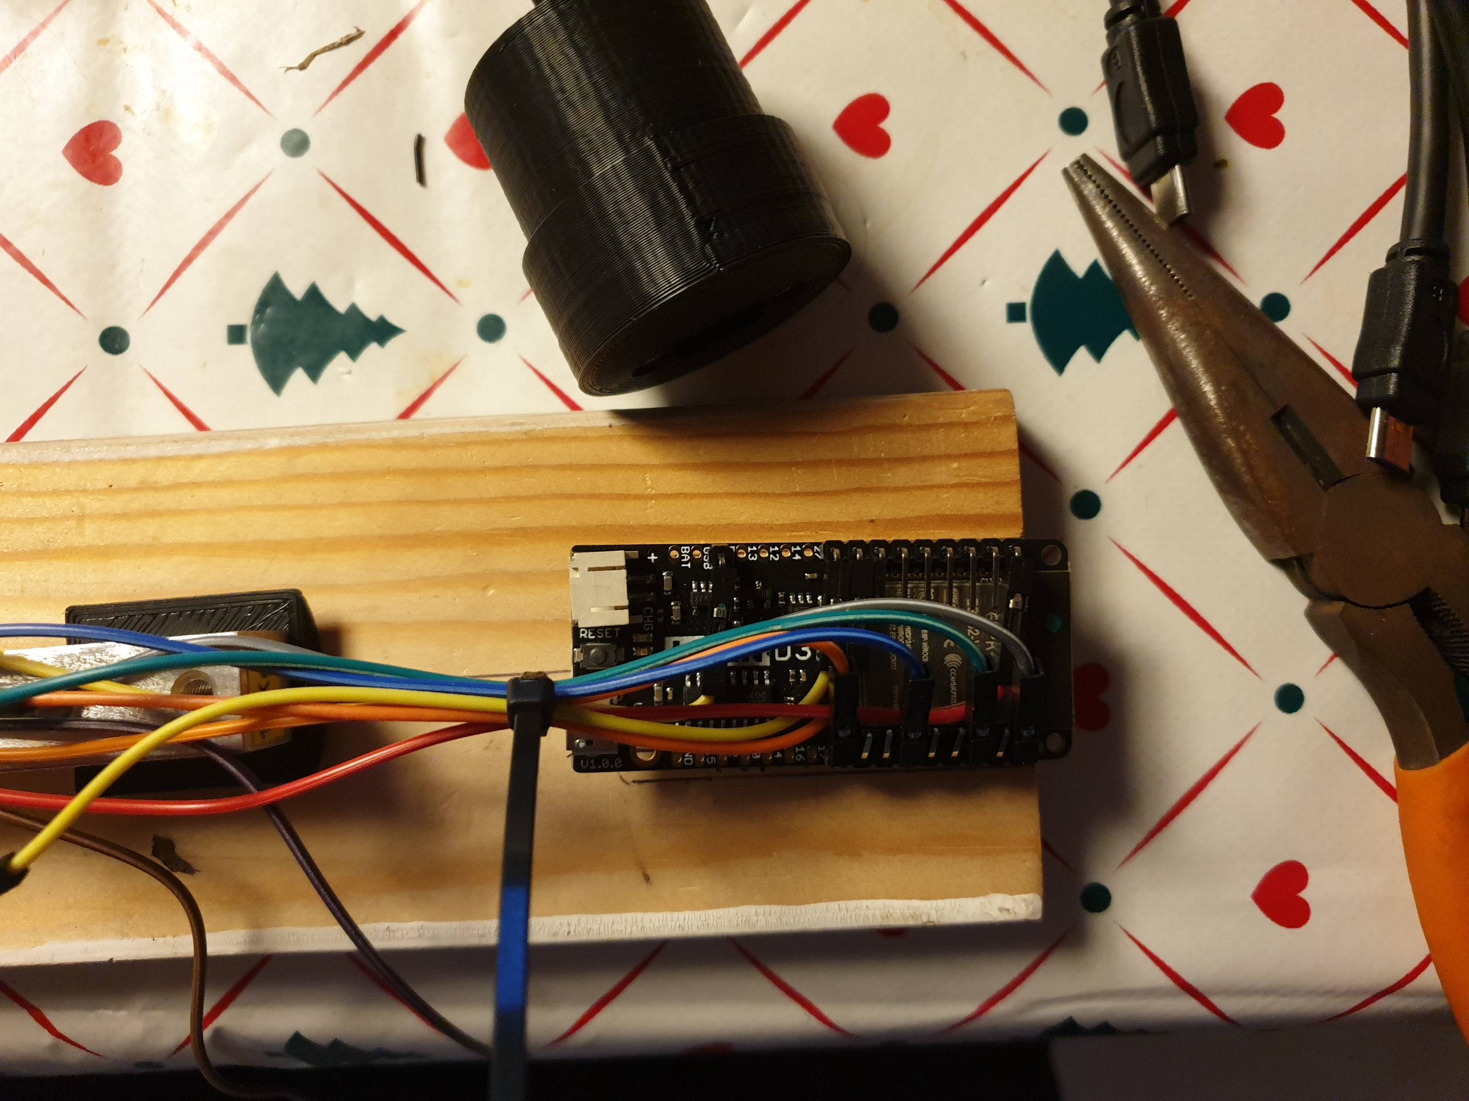

#### Bottom assembly

Insert the Lolin D32 board inside the 3D printed bottom, with the USB mount below the Lolin D32 board. It might be necessary to apply additional bend on the pins on the Lolin D32 board in order to make it fit.

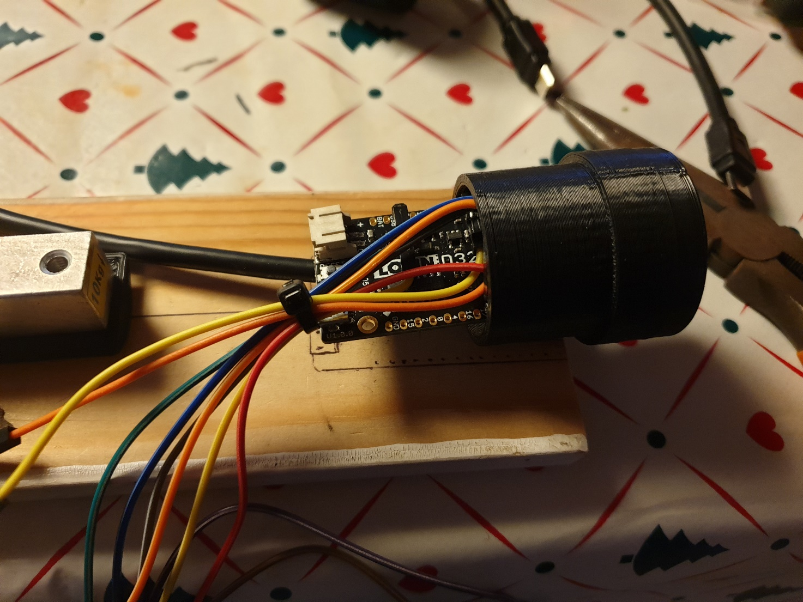

#### Attachment to load cell

Take the 3D printed spacer, an M2x6mm screw, a M4 nut, and an M4x6 screw, and attach the spacer to the load cell and the Lolin D32 board. Make sure the wiring goes over and below the 3D printed spacer as seen in the picture. The 2 10 cm jumper wire should go straight to the direction of the load, and the 3.3V and GND wire pointing towards the bottom should likewise be directed back to the load cell.

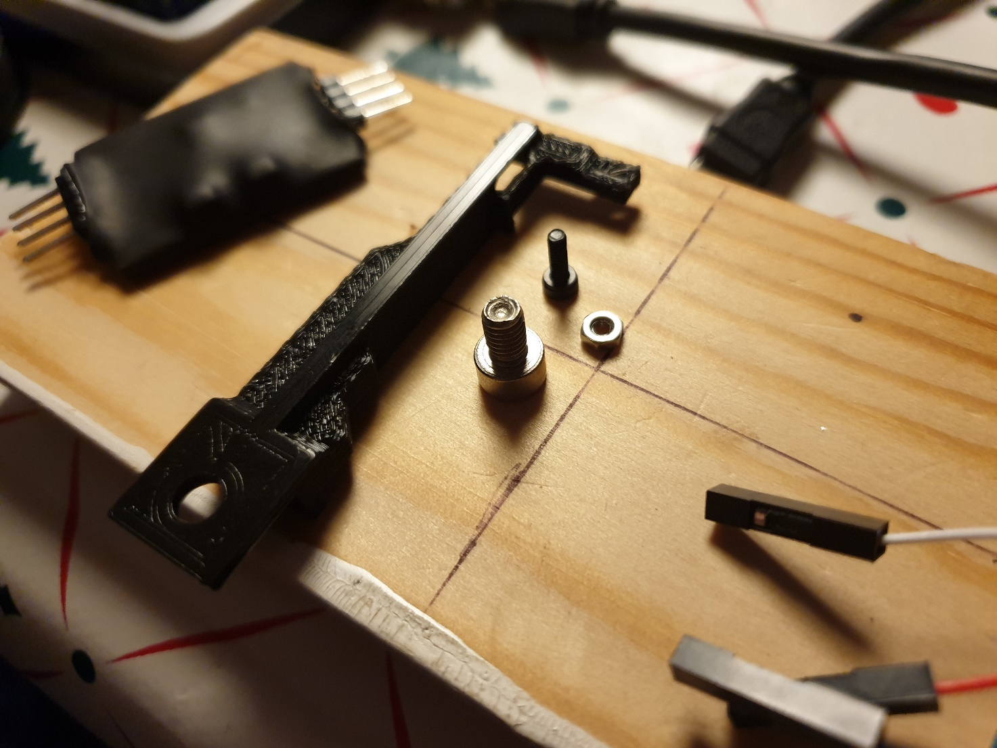

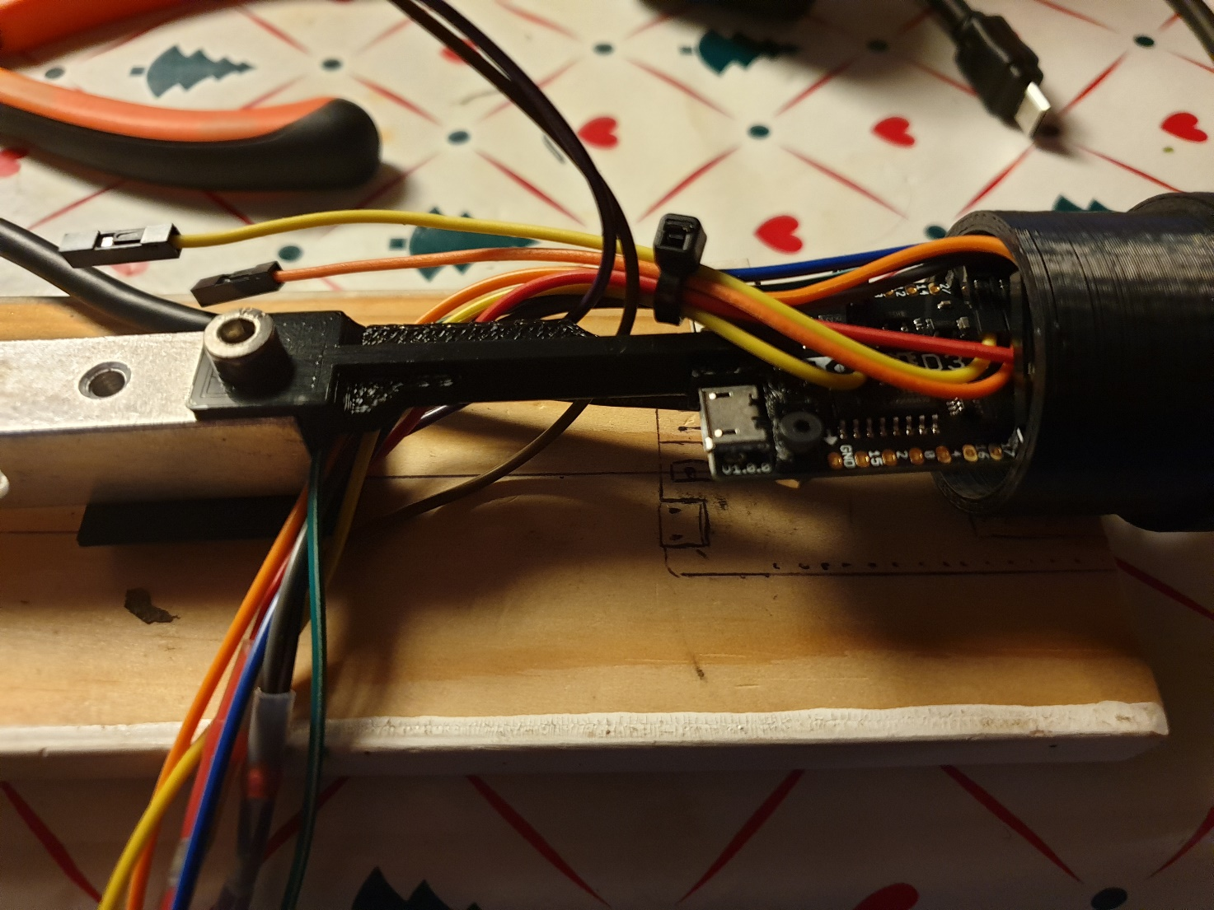

#### Attach the LiPo battery

Connect the LiPo battery to the connector, if the connector does not fit, cut of the side guides from the battery connector with a knife. The battery should be place beneath the Lolin D32 board, but above the USB cable.

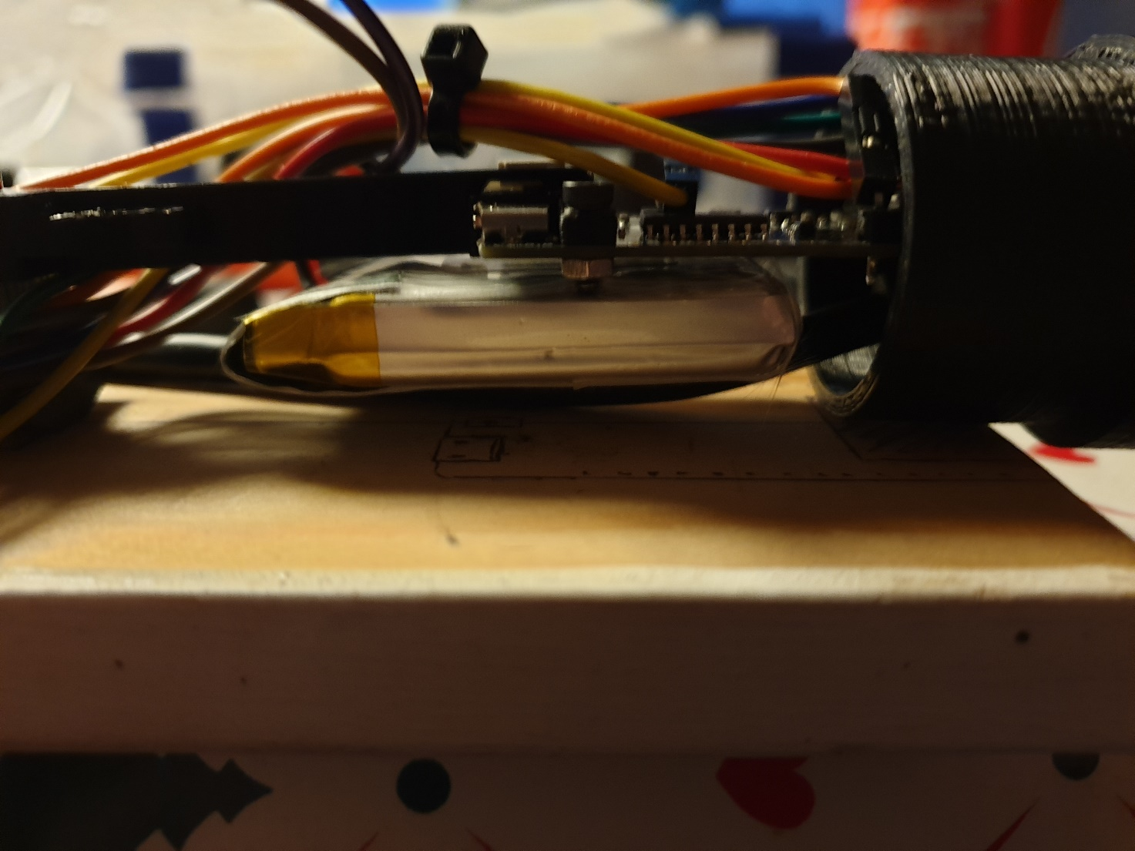

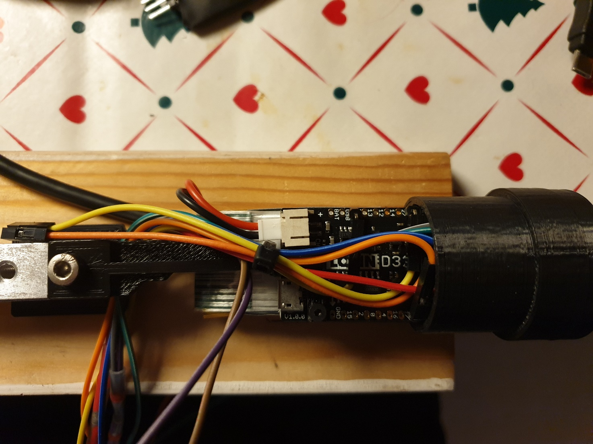

#### Micro USB cable

The Micro USB cable should go through the Load cell cutout, and up to the Micro USB connection on the Lolin D32 board.

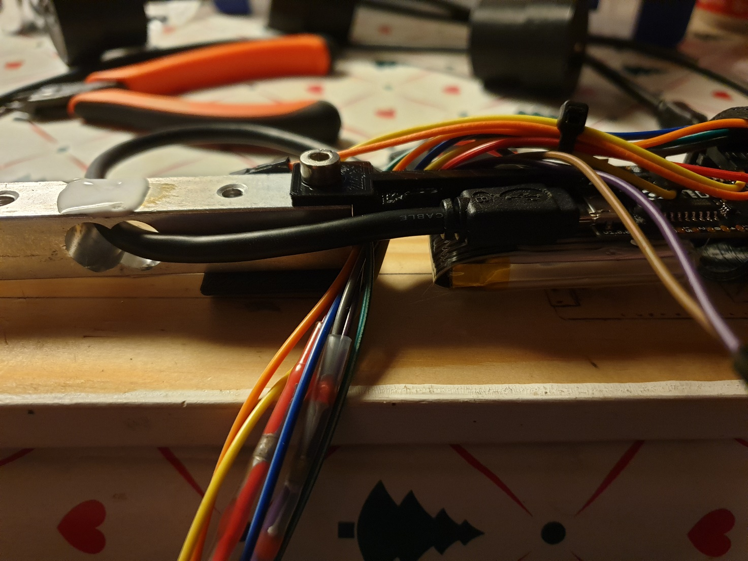

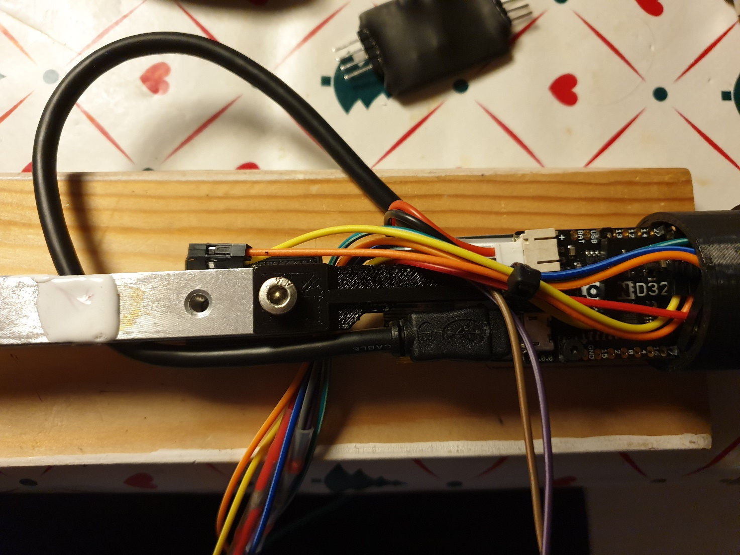

#### HX711

The Load cell amplifier, HX711, is to be fitted loosely on top of the load cell. Place and connect the wires as follows:

From load cell to HX711:

* RED wire -> RED
* BLACK wire -> BLK
* WHITE wire -> WHT
* GREEN wire -> GRN

From wire harness:

* 3.3V -> VCC
* Pin 26 -> DAT
* Pin 25 -> CLK
* 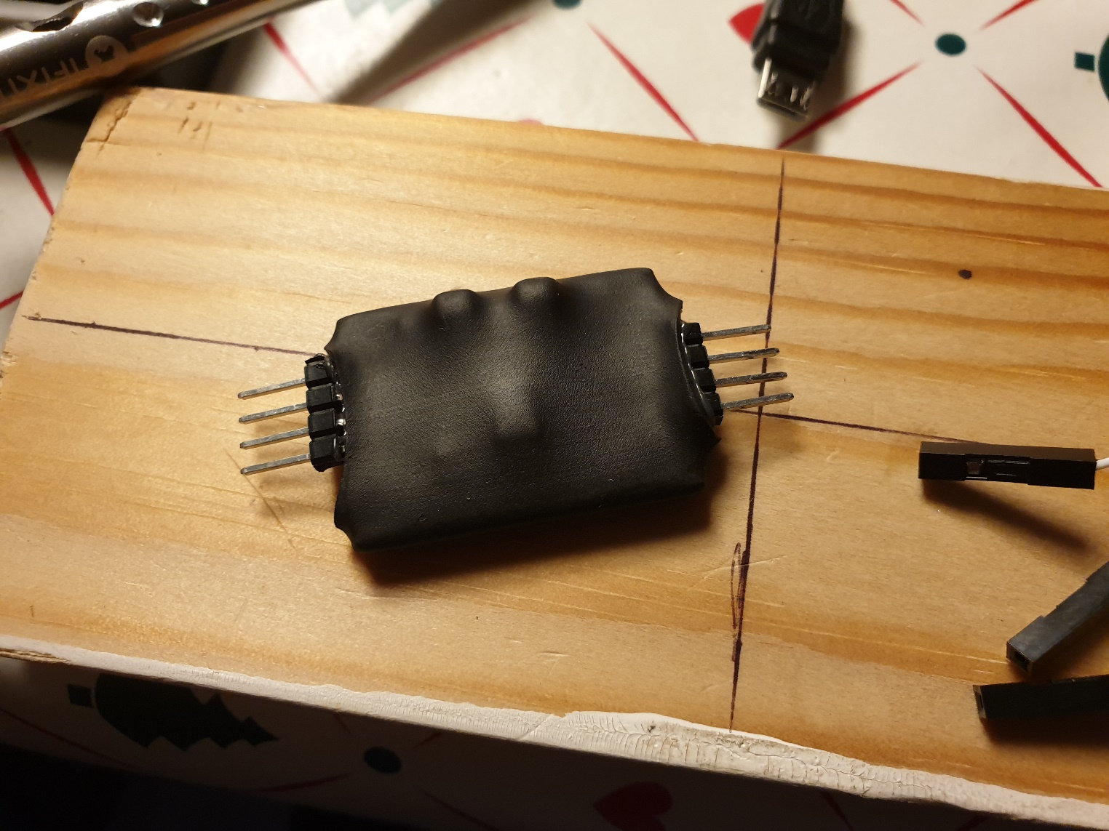GND -> GND



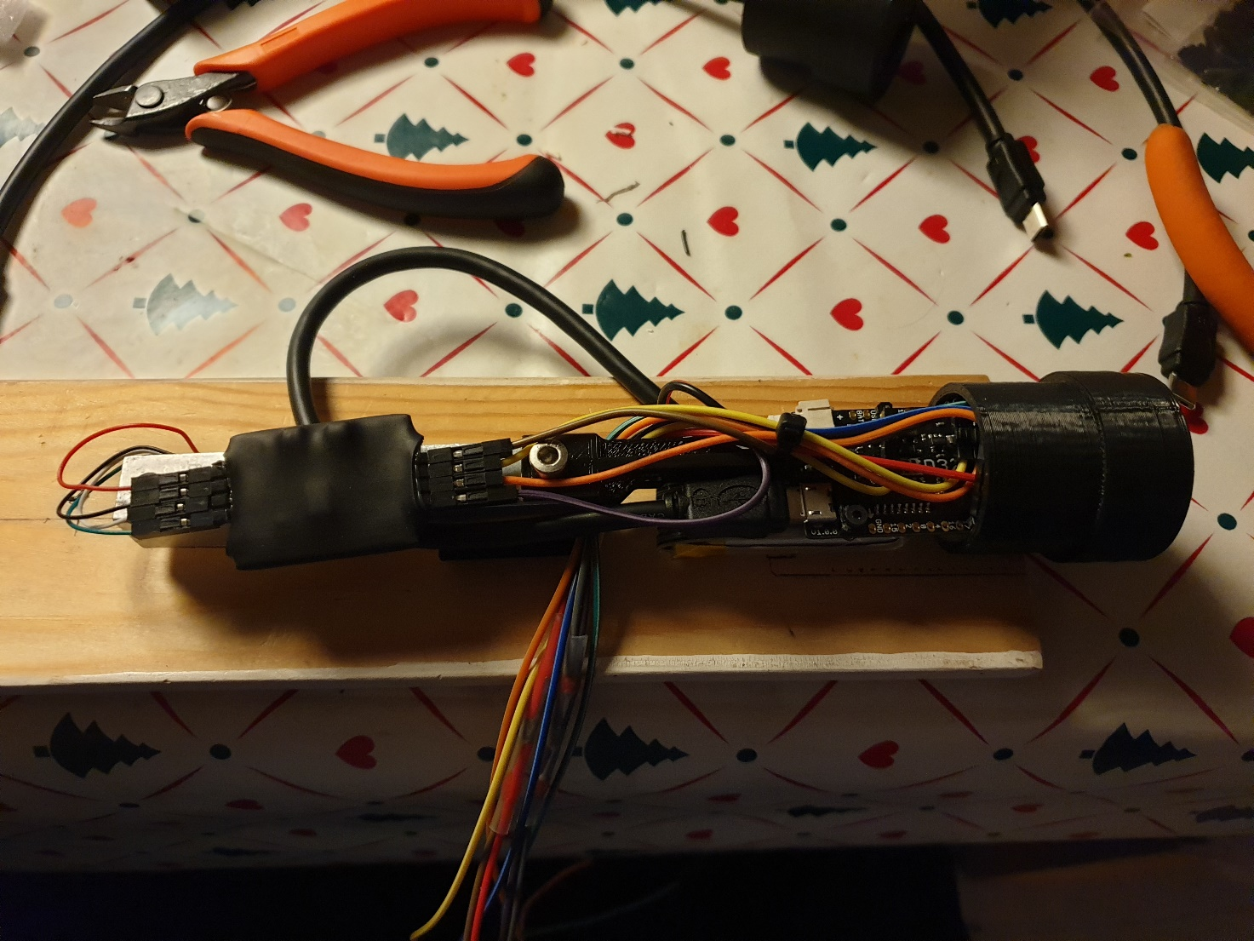

#### LED button

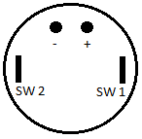Connect the LED button as follows:

From wire harness to LED button

* 3.3V -> +
* Pin 5 -> -
* EN -> switch/terminal 1
* GND -> switch/terminal 2

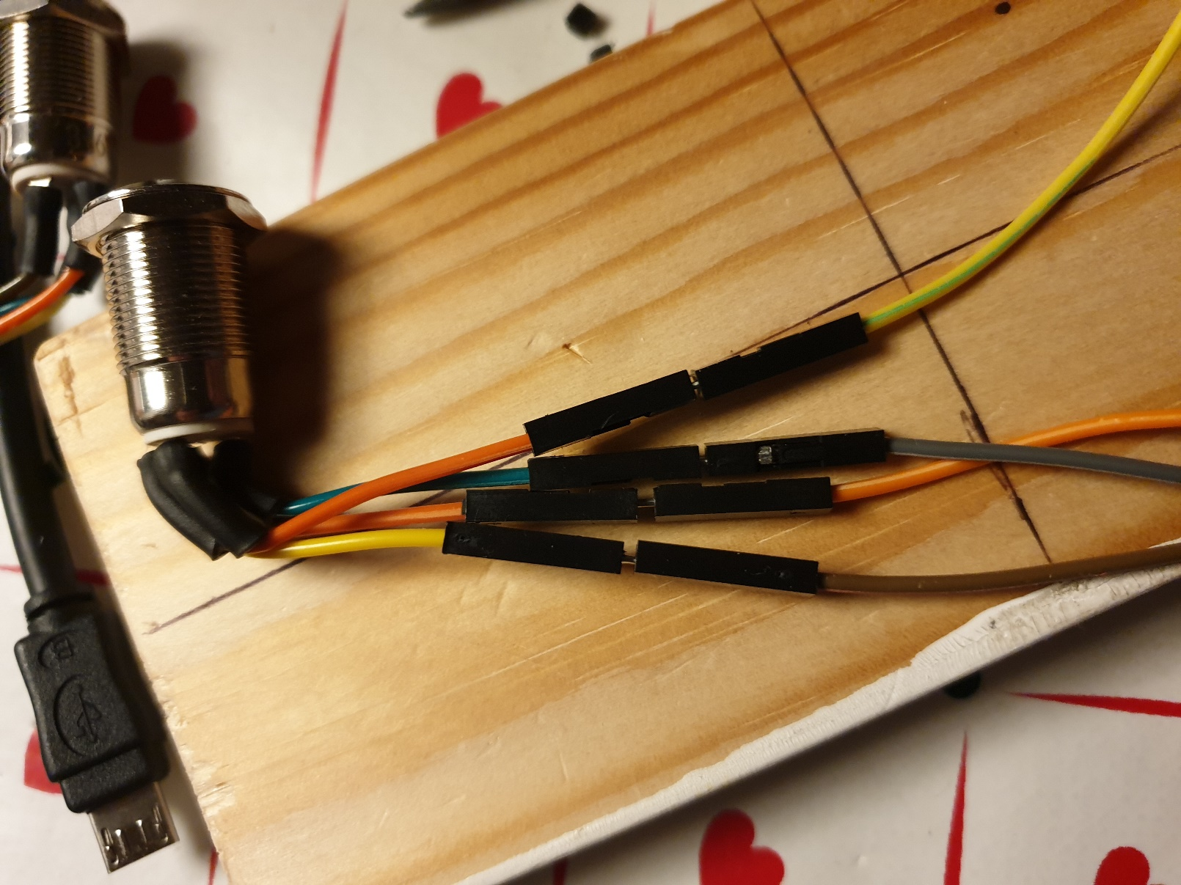

#### OLED display

Connect the wire harness with the OLED display as follows:

* 3.3V -> VCC
* SDA -> SDA
* SCL -> SCK
* GND -> GND

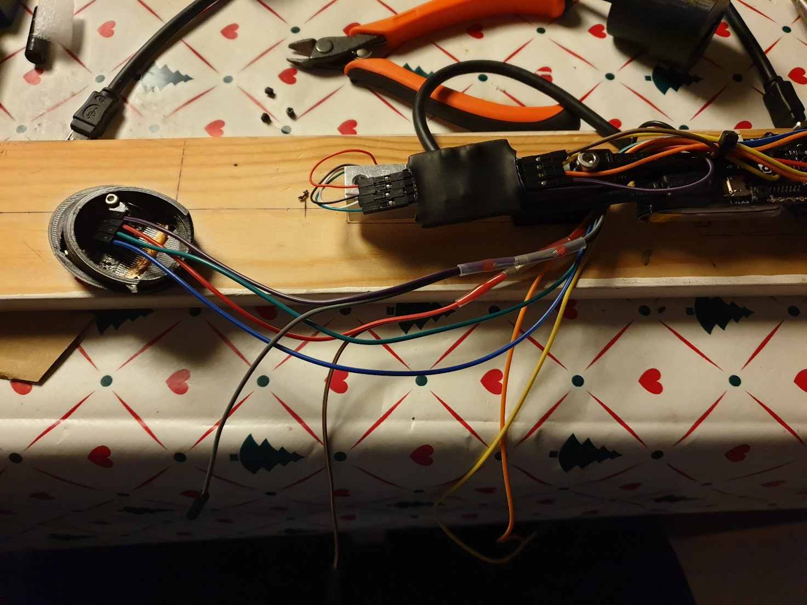

### Pre TEST before complete assembly

#### Upload software

Following all of the above steps should leave you with a fully functioning unit, outside of the aluminium tube. Before proceeding with inserting the assembly in the aluminium tube, we are going to test the unit for assembly mistakes.

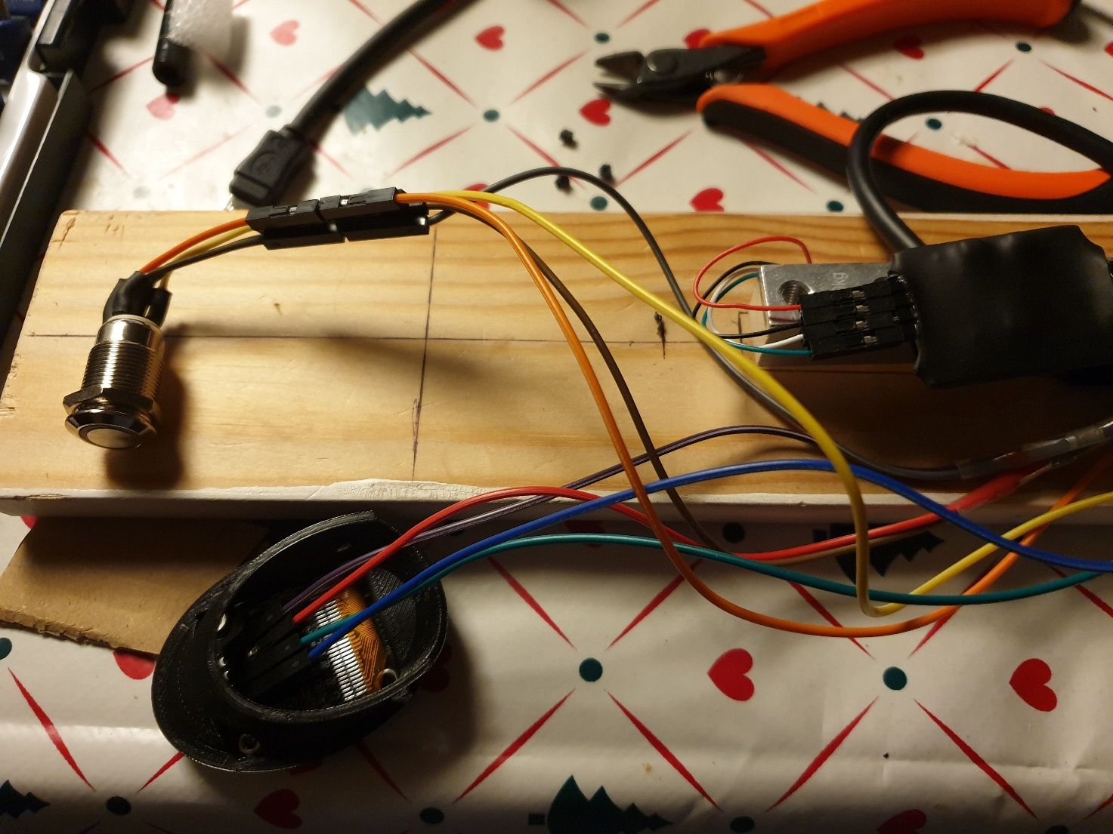

Connect a micro USB cable in the bottom of the unit, to a PC, and upload the software as described under the Software chapter.

#### WiFi configuration

When the software has been successfully uploaded, the LED button should blink, and a LOGO should appear on the OLED display.

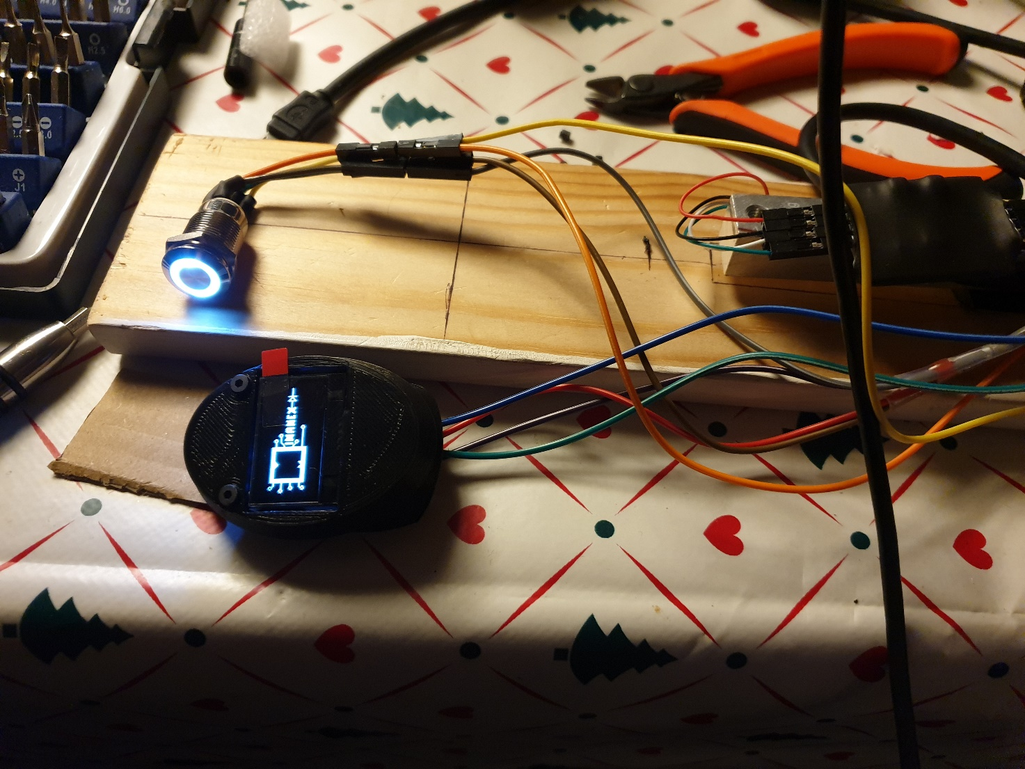

During startup, the device will try to connect to a known WiFi, if any saved WiFi networks exist on the unit. During first startup, no WiFi networks are known, and the device will create a WiFi access point, with SSID named: PressureProbe

Instructions will appear on the OLED display, along with the password for the access point, which is needed in order to connect to the unit, and configure the WiFi configuration of the device.

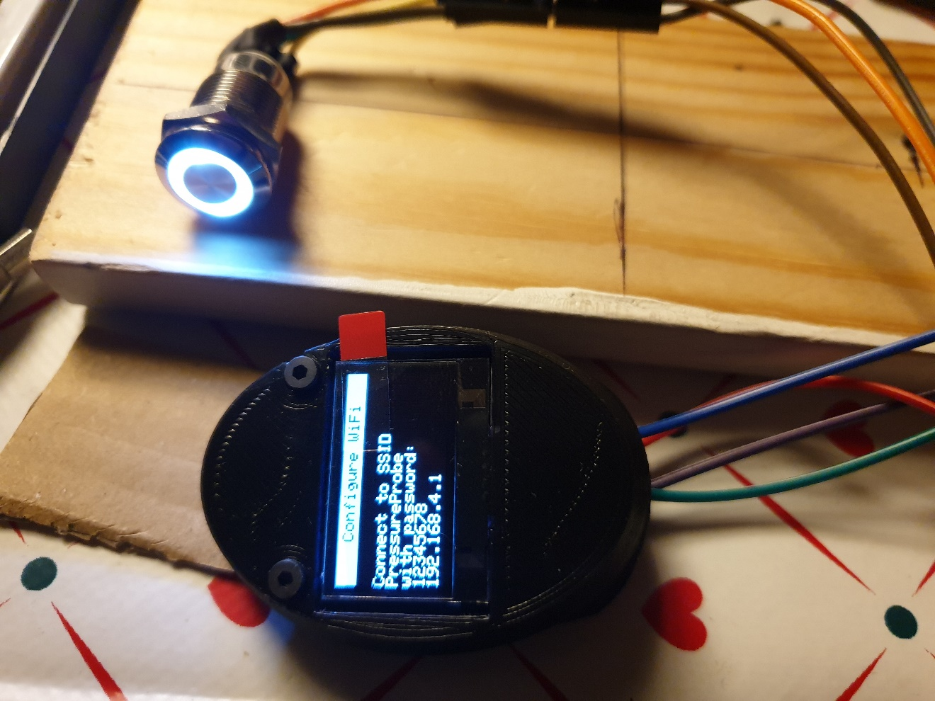

When connected to the access point, PressureProbe, a browser should automatically open, and direct to the WiFi configuration page. If not, when connected to the access point, type in the IP address displayed on the OLED, and a configuration page is presented.

Click on configure WiFi and insert the appropriate credentials to whichever WiFi network you connect to.

The OLED will after successfully connected to the specified WiFi, write that a reboot of the device is needed. Turn off, and then on the device when the message appears.

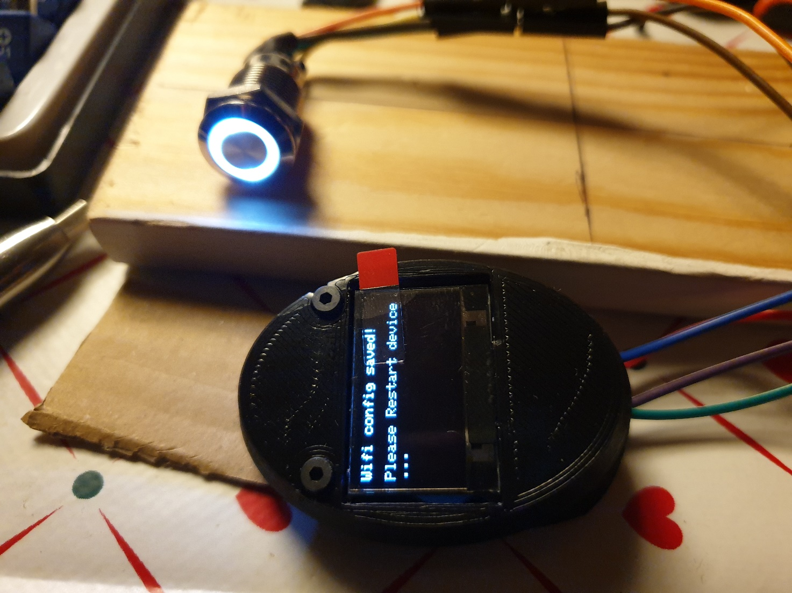

#### Access the web server

After successfully configuring the WiFi, and rebooting the device, the display will write an IP address on which the webserver is hosted. Type the IP address in a browsers URL to connect.

Attach the aluminium probe tip to the load cell.

Go to the ‘RAW DATA CAPTURE’ page and press the ‘save to file’ checkbox to initiate raw data capture.

The OLED should show a gauge on the display.

The gauge needle should go upwards, and the value in the bottom of the display should increase when the aluminium tip is being **pulled upwards, not when pressed down**. If nothing happens, there is a wrong connection, or the load cell is mounted upside down. Correct the problem and conduct the test again.

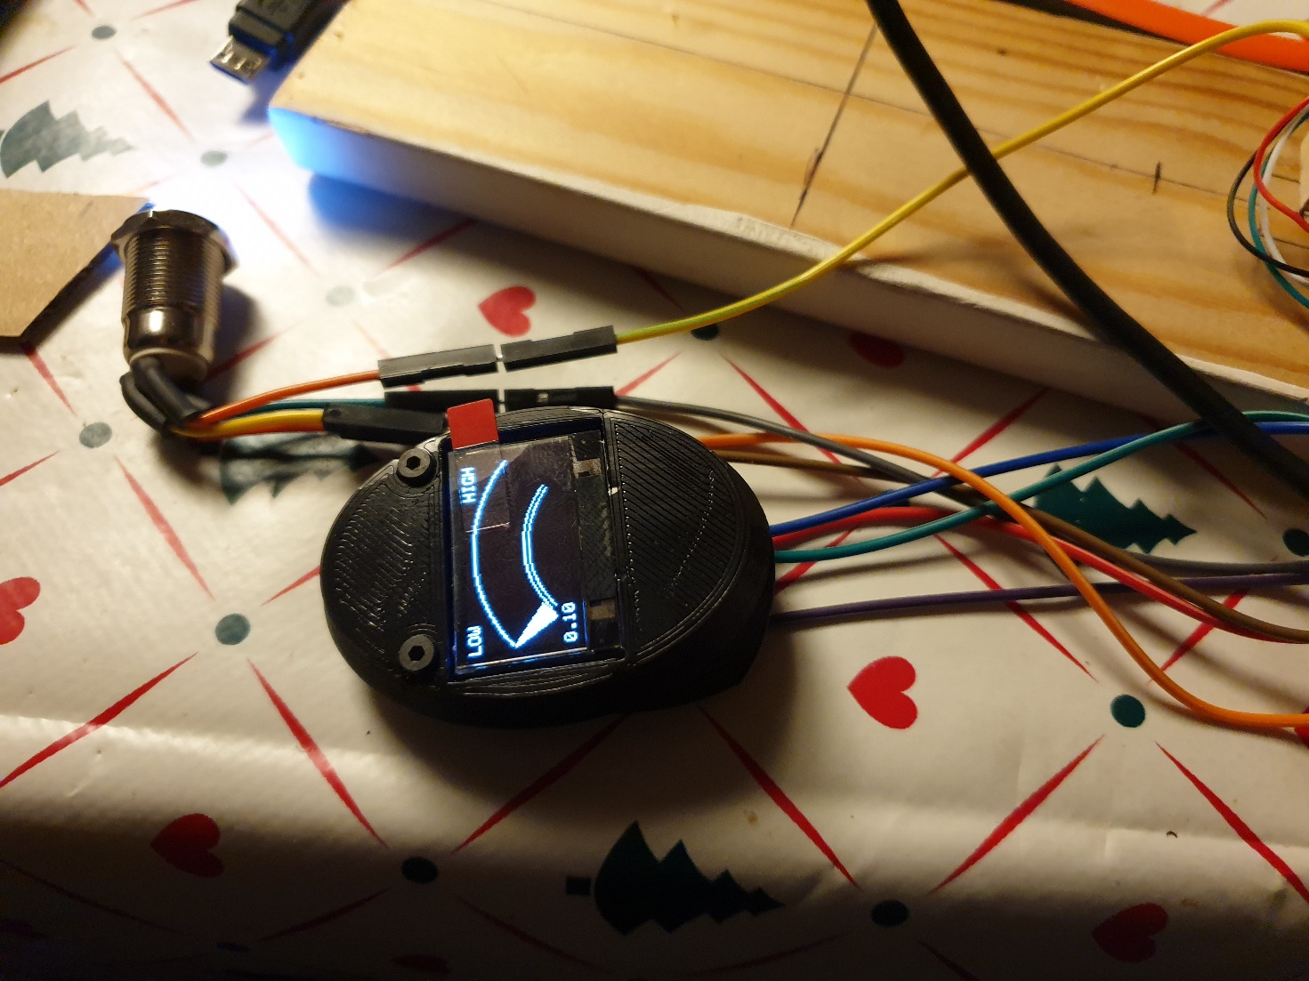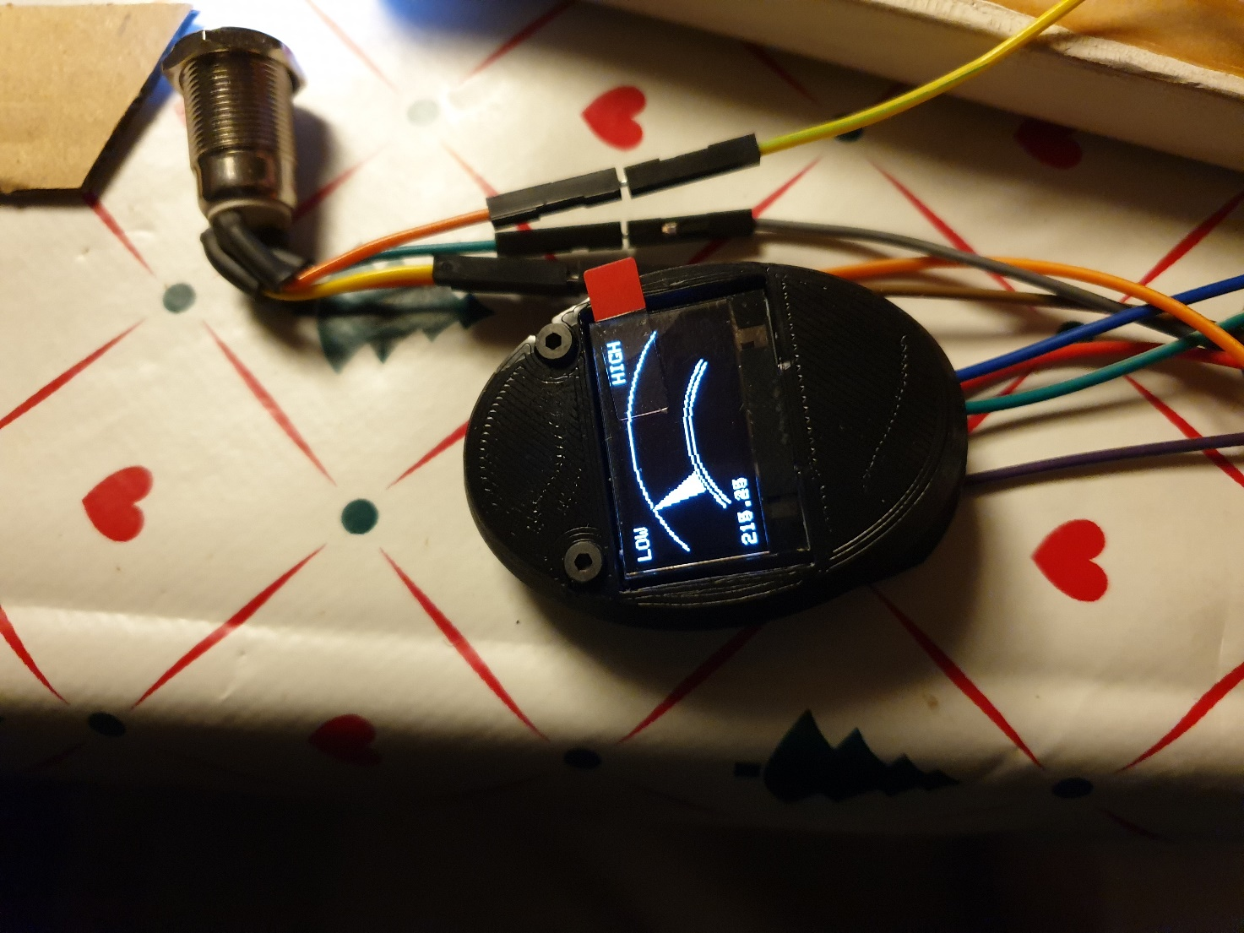

When the test is succesfull, dismount the LED button and OLED display, the device is ready to be fully assembled inside the aluminium tube.

### Completing assembly

Dismount the assembly from the wood, and take the 3D printed tube spacer, and insert it in the aluminium tube. Fasten it with 2 M4x16mm screws. Make sure the screws does not go all the way through the tube spacer, as this will prevent the assembly from being inserted. Try to make the spacer as level and plane with the tube as possible.

Drill an appropriate hole size close to the very top of the aluminium tube for the self tapping screw. It might be necessary to drill a hole in the 3D printed top as well, to prevent the 3D printed top to crack when the screw is inserted.

Insert the assembly with the wires first, in the aluminium tube. The assembly is to be mounted on the tube spacer in the same way it was assembled on the wooden board. Be cautious when inserting, not to catch wires or put excessive force one the assembly, as this might destroy wires, or disconnect connections.

8 wires should be going through the top of the aluminium tube.

Unscrew the nut on the LED button, and insert it in the aluminium tube, slide the nut on the LED button wires, and connect the correct wires as during the pre test. Turn the wires downward inside the tube, and fasten the nut.

Connect the wires to the OLED display, and insert the OLED assembly in the aluminium tube top. Insert the self tapping screw to secure the top assembly to the aluminium tube.

The device is fully assembled, Turn on the device, and ensure all functionality is intact.

# Troubleshooting

The risk for malfunctioning are more likely to encounter during assembly. For the most part, when something is not functioning, like the OLED or LED button, the problem is with the connections on the Lolin D32 board. When the Lolin D32 board is mounted in the bottom 3D printed part, the pins can bend to the extend where they no longer have a sufficient connection to the board.

To correct or check the connections, it is only necessary to unscrew the 2 M4x16mm screws which secure the load cell to the tube. Hereafter it is possible to extract the electronics out the bottom, to the limit of the wires connected to the OLED and LED button. Find the affected pin, and try to squeeze the metal part of the pin tighter together, to make the connections sufficient again. It can also help to increase the angle of the bend pin headers on the board to be more horizontal, in order to prevent the 3D printed bottom to pull or drag in the wires when assembling.